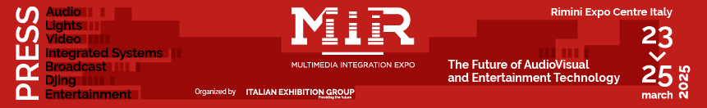

press release no.8
(English translation)

GETTING TO MIR IS EASY, FAST AND ACCESSIBLE TO ALL

Service guide for the Multimedia Integration Expo, taking place from March 23 to 25
at Rimini Expo Centre (Italy).

Rimini (Italy), 23-25 March 2025 – How to get to MIR – Multimedia Integration Expo 2025? Italian Exhibition Group has organised various transport services to make it easy for visitors and operators to reach the expo centre and participate in the event.

Access to the expo centre: from Hall Sud (via Emilia, 155).
Event times: Sunday 23 to Monday 24 March, from 10:00 to 18:30. Tuesday, March 25, from 10:00 a.m. to 5:00 p.m.
Ticket office: admission upon registration. €16 (1-day admission) or €12 (1-day admission, available online until March 22)
Visitor helpdesk: for assistance, call +39 0541 744555 from Monday to Friday, 9:00 am to 1:00 pm, or email helpdesk.rn@iegexpo.it. Alternatively, fill out the online form at this link.
We recommend pre-registering at this link, printing your ticket, and heading straight to the turnstiles.

GETTING TO THE EXPO
Trains: Rimini Expo Centre (Italy) boasts a unique feature on the Italian exhibition scene: an internal railway station on the Lecce-Milan/Milan-Taranto line. Train schedules from the North to Rimini Fiera are available at this link, and from the South to Rimini Fiera qui. Schedules may vary, so we recommend checking the Trenitalia website as well. Simply enter Rimini Fiera as your departure or destination, along with the exact date. RFI offers a special assistance service for passengers with disabilities and reduced mobility, which must be booked at least 12 hours in advance. The service is exclusively for assistance in getting on and off the train and does not include accompaniment within the expo centre. The meeting point is located at the railway station's ticket office. You can find more information on the RFI website, under the 'Station Accessibility' section.
- IMPORTANT NOTICE: On Sunday, March 23, due to issues on the railway line between Imola and Forlì, all trains arriving and departing from Rimini will be diverted through Ravenna, bypassing the Riminifiera station. Our station will remain closed, leaving Rimini Centrale as the sole station in operation.
Trains will stop at Riminifiera on Monday 24 and Tuesday 25.
Public transport: From Rimini Centrale Railway Station, take bus number 9, coinciding with the arrival of Metromare buses during peak hours, or number 9 bis, which runs non-stop. From Rimini Sud (Miramare), take number 10, and from Rimini Nord (Torre Pedrera), take number 5. More information at this link. To access public transport services, a valid travel ticket is required. Several multi-day pass options are available. More details here.
Electric mobility: bicycles, e-bikes, and electric scooters from the sharing company Lime and BIT MOBILITY can be used to move around the expo centre. Simply download the apps from Google Play Store or App Store. Discover more about discounts and promotions on this link.
Cars, parking, car rental, chauffeur-driven car rental, and taxis: Rimini Expo Centre (via Emilia 155, is conveniently connected to the A14 motorway network, Bologna-Bari-Taranto, which in turn links to the main European motorways. It's just 6 kilometres from the Rimini Nord motorway exit. Exhibitors and visitors can access six charging stations in the parking lots, offering a total of 12 sockets (Type 2, with cables provided by the user). To make your journey to the venue with a rental car, AVIS Autonoleggio offers special rates to and from Rimini Fiera. For more information, contact (+39) 0541/51256 - 199 100 133 - www.avisautonoleggio.it.
You can choose between regular taxi services or the Taxi Sharing (collective taxi) offered by the CO.TA.RI cooperative. For more information, call (+39) 0541 50020 or visit www.radiotaxirimini.it

For all services available for reaching MIR, visit the website: https://www.mirtechexpo.com/mir/info-utili/come-arrivare

ABOUT MIR 2025
Date: 23/25 March 2025; event type: international expo; organizer: Italian Exhibition Group S.p.A.; recurrence: annual; edition: 9th; open to: general public and professional operators; info: www.mirtechexpo.com

PRESS CONTACT ITALIAN EXHIBITION GROUP
head of corporate communication & media relation: Elisabetta Vitali
press office manager: Marco Forcellini, Pier Francesco Bellini | press office coordinator: Luca Paganin | international press office coordinator: Silvia Giorgi | press office specialist: Mirko Malgieri; Nicoletta Evangelisti | media@iegexpo.it

MEDIA AGENCY MIR
Naper Multimedia| Zoe Perna | T. +39 02 97699600 | zoe.perna@napermultimedia.it | staff@napermultimedia.it

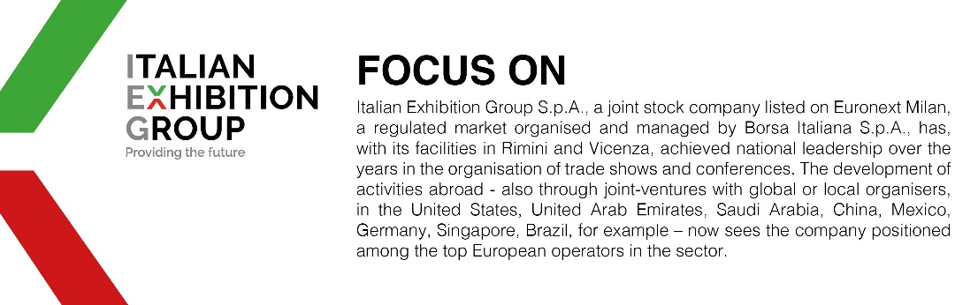

This press release contains forecast elements and estimates that reflect the management´s current opinions (´forward-looking statements´), particularly regarding future management performance, realization of investments, cash flow trends and the evolution of the financial structure. For their very nature, forward-looking statements have a component of risk and uncertainty, as they depend on the occurrence of future events. The effective results may differ (even significantly) from those announced, due to numerous factors, including, only by way of example: food service market and tourist flow trends in Italy, gold and jewellery market trends, green economy market trends; the evolution of raw material prices; general macroeconomic conditions; geopolitical factors and evolutions in the legislative framework. Moreover, the information contained in this release, does not claim to be complete, and has not been verified by independent third parties. Forecasts, estimates and objectives contained herein are based on the information available to the Company as at the date of this release.

